# INNOVATIONS OF ENVIRONMENTAL MONITORING

Here are some innovative ideas for environmental monitoring:

1. Smart Trash Bins: Develop trash bins equipped with sensors to monitor waste levels. When they are full, they can send alerts to waste management services for efficient collection.

2. Air Quality Drones: Use drones equipped with air quality sensors to monitor pollution levels in real-time. These drones can provide valuable data for assessing and mitigating air pollution.

3. Ocean Monitoring Buoys: Deploy autonomous buoys in the ocean with sensors to monitor water quality, temperature, and marine life. This can help detect environmental changes and protect marine ecosystems.

4. Urban Green Spaces Monitoring: Create a network of sensors in urban green spaces to monitor factors like soil moisture, air quality, and biodiversity. This data can inform maintenance and conservation efforts.

5. Wildlife Tracking Apps: Develop smartphone apps that allow users to report wildlife sightings and track migration patterns. This crowdsourced data can aid in wildlife conservation.

6. Noise Pollution Mapping: Create a platform that collects and visualizes noise pollution data from citizen reports and sensor networks. This can help identify noise hotspots and inform urban planning.

7. E-waste Tracking: Implement a system to track the disposal and recycling of electronic waste. This ensures proper handling and reduces the environmental impact of electronic devices.

8. Food Supply Chain Monitoring: Use blockchain and IoT devices to track the environmental footprint of food products throughout the supply chain. This can promote sustainable agriculture and reduce food waste.

9. Forest Fire Prediction: Develop AI algorithms that analyze various environmental factors to predict and prevent forest fires more effectively.

10. Water Quality Sensors: Distribute low-cost water quality sensors to communities, allowing them to monitor the safety of their drinking water sources.

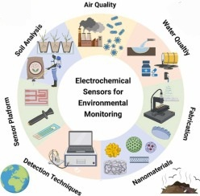These ideas leverage technology and data to enhance environmental monitoring and contribute to sustainability efforts.

Sensors are devices or instruments that detect and measure physical properties or changes in the environment. They play a crucial role in various applications, including environmental monitoring. Common types of sensors used in environmental monitoring include:

1. Temperature Sensors: Measure temperature variations in the environment.

2. Pressure Sensors: Monitor changes in atmospheric or water pressure.

3. Humidity Sensors: Measure the moisture content in the air.

4. Gas Sensors: Detect specific gases like carbon dioxide (CO2), methane (CH4), and ozone (O3).

5. Water Quality Sensors: Assess parameters like pH, dissolved oxygen, and turbidity in water bodies.

6. Light Sensors: Measure light levels, which is vital for assessing plant growth and solar radiation.

7. Motion Sensors: Detect movement, useful in wildlife monitoring and security applications.

8. Soil Sensors: Evaluate soil parameters like moisture content and nutrient levels.

9. Sound Sensors: Capture sound data, valuable for monitoring noise pollution and wildlife behavior.

10. Remote Sensing: Instruments like satellites and drones use sensors to collect data from a distance, providing a broader perspective on environmental changes.

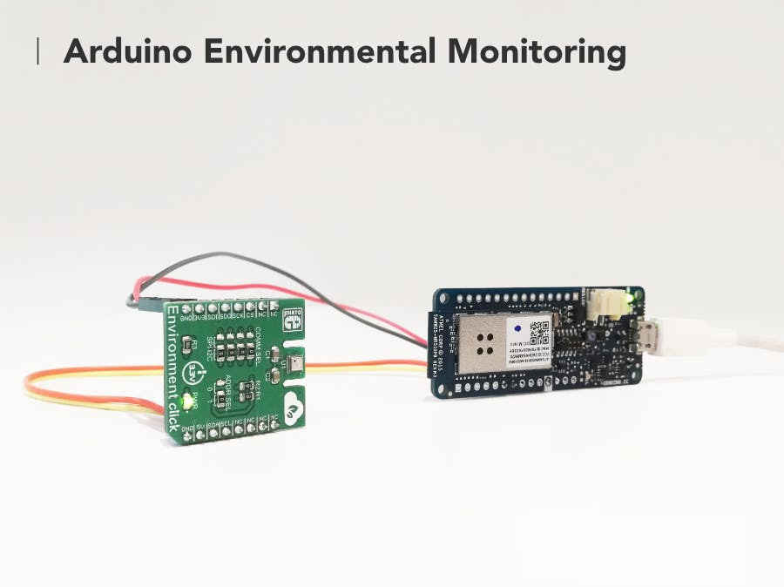These sensors provide valuable data for environmental scientists, policymakers, and organizations to monitor and address issues like climate change, pollution, and habitat conservation.